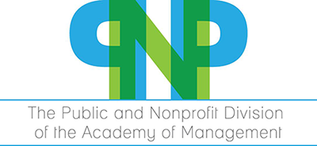

2019 Best Book Award Announcement

The Best Book Award Selection Committee for the Public and Nonprofit Division of the Academy of Management is requesting nominations for the Division’s 2019 Best Book Award. Books nominated should have publications dates of 2016, 2017, or 2018.
The best book will receive an award of $1000 (USD) sponsored by Deloitte Global Services.
Members of the Public and Nonprofit Division pay special attention to how distinctive qualities of the public and nonprofit sectors influence management and organizational processes. Books nominated for the Award should significantly contribute to modern management theory and/or practice and address issues within the Public and Nonprofit Division’s domain of interest. Author membership in the Division or the Academy of Management is not a criterion in the award process. Because of the interest in the substantive intellectual contribution of the book, nominations of textbooks, or books of previously published papers are discouraged. The winning author(s) will receive a plaque recognizing the award.
Nominations for the award should include the author’s name, book title, publisher, date of publication, and short paragraph supporting the nomination. Self-nomination is allowed. Nominations are due March 4, 2019.
Nominations should be sent to the committee chair, Robert M. Yawson at robert.yawson@qu.edu. Committee member addresses will be provided to those submitting nominations to arrange for copies to be sent to all members of the committee.

