PDIB–CIBER INDIA 2022
DAY 1: 27 DEC`22 (TUE) DEPART U.S.A
Depart U.S.A.

DAY 2: 28 DEC’22 (WED) ARRIVE DELHI
Arrive Delhi late night

After clearing customs and immigration formalities, proceed towards the arrival lounge of the airport where you will be welcomed and assisted by our representative.

Later, transfer to hotel. (Rooms blocked from 3.00 PM – supplement payable if arriving earlier)

Delhi is a city that defies a one-line description as the capital of India or as the capital of the world’s largest democracy. Actually, Delhi is India in miniature; it is 3,287,263 sq. km of India’s fantastic variety compressed into 1,483 sq. km. Over the millennia, it has wooed rulers, attracted plunderers, and provided historians with so many details. Today, even as it preserves an enviable heritage, Delhi is a true cosmopolitan city, always on the move. Delhi remains the centre of power. Once it was a city of royal power. Then it became the seat of colonial power. Later it was the seat of bureaucratic power. The seat of political power it has always been. Today it is emerging as an important centre for corporate power too. However, the most fascinating aspect of this city is its cosmopolitan nature.

Overnight : Delhi
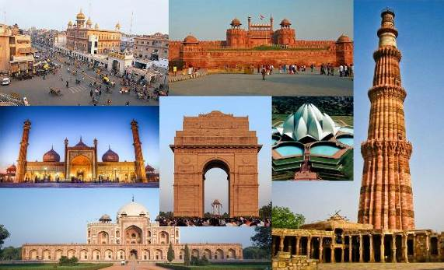
Meals : None

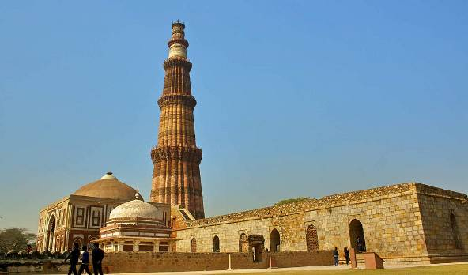
DAY 3: 29 DEC`22 (THU) DELHI

Breakfast at the hotel.

1000hrs: Shor Orientation Meeting at the hotel.

Visit the Qutab Minar, a Tower of Victory, built in the 12th century by Qutbuddin Aibak. Within its spacious courtyard stands the Iron Pillar, which dates back to the 4th century AD and bears a Sanskrit inscription in the Gupta style. The pillar has puzzled scientists, as its iron has not rusted in all these centuries.

Drive through the streets of New Delhi, past the architecture of British India - the imposing President’s House, the North and South Blocks, the government offices and Parliament House and India Gate, the memorial to the Unknown Soldier. Also visit the Agrasen Ki Baoli is one of the most important baolis of Delhi. Also known as Agrasen Ki Baodi, the historical monument is being protected by the Archaeological Survey of India under the Ancient Monuments.

Lunch at a city restaurant

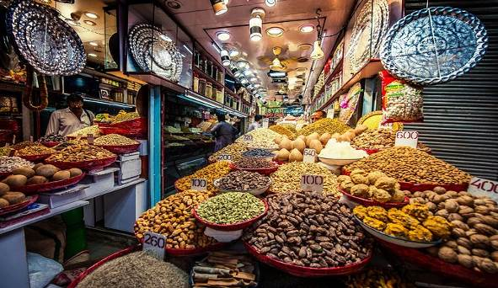

Drive to Old Delhi. Explore the living legacy of the Indo-Islamic culture & lifestyle in Old Delhi. Moghul emperor Shahjahan transferred his capital from Agra to Delhi and laid the foundations of Shahjahanabad, the seventh city of Delhi. Today it is popularly called Old Delhi. There is no better way to explore this bustling part of the city than on a cycle rickshaw. Ride through the narrow lanes and experience the daily activities of the merchants, the little food and traditional stalls and the teeming population busy in daily activities. Visit Khari Baoli, Asia’s largest spice market. Stroll through the bustling, busy lanes of the area. The displays of hundreds of spices and condiments are arranged in neat colourful piles making it a visual treat. Also visit the Jama Masjid (Friday Mosque), India’s largest mosque, also built by Shah Jahan.

Evening: A Special Welcome Dinner

Overnight : Delhi
Meals : Breakfast & Dinner

DAY 4: 30 DEC`22 (FRI) DELHI
Breakfast at the hotel.

Full day Business Meetings

Overnight : Delhi
Meals : Breakfast

DAY 5: 31 DEC`22 (SAT) DELHI / AGRA

Breakfast at the hotel, check out and drive to Agra (approx. 4hrs)

The ancient city of Agra lies on the banks of the river Yamuna and is one of the oldest settlements of India. Between the 16th and 17th C it was the seat of power of the Mughals and three generations of Great Mughals ruled a huge empire from here. It was also a centre of learning, Culture, Art and Religious philosophies which produced some of the most renowned litterateurs and scholars.
Assistance upon arrival and check-into hotel.

Lunch at a city restaurant

Visit the Agra Fort, strategically situated along a bend on the Yamuna River. Built 16th century AD by three generations of Mughal emperors, it is a superb synthesis of stern military fortifications with delicate interior details. The Mughal Emperor Shah Jahan was imprisoned by his son here. Here you will see the art and crafting of the white marble that has made the area so famous, and the Halls of Public and Private Audience.
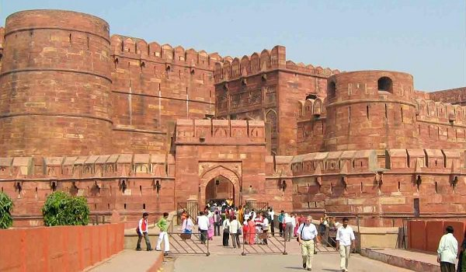

Evening: New Year’s Eve Gala Dinner

Overnight : Agra
Meals : Breakfast, Lunch & Special New Year’s Eve Dinner
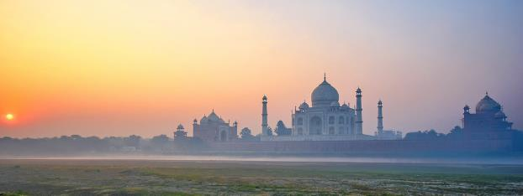
DAY 6 : 01 JAN` 23 (SUN) AGRA / DELHI / KOLKATA
Happy New Year
Early this morning, visit to the Taj Mahal at sunrise. The Taj Mahal is the finest architectural achievement of the Moghuls, and maybe of all mankind. Built over a period of 22 years by the Mughal Emperor Shah Jahan in 1630 for his Queen Mumtaz Mahal to enshrine her mortal remains, it is one of the Seven Modern Wonders of the World.

Return to hotel for breakfast.
Later check-out of the hotel drive back toDelhi.

Lunch at a midway restaurant.

Upon arrival transfer directly to the airport to board flight for Kolkata.
Vistara Flight UK 707 (1730/1935 hrs.)

Kolkata has been the capital city of India, in the times of British Raj for quite a long period and is often referred to as the intellectual capital of the country. Kolkata, unlike any other city of India is a unique hub of culture and heritage. There are several interesting monuments dating back to the period of the British Raj, that are landmarks of Kolkata today. A city that was a small village in the 17th century, Kolkata has developed into a modern city dotted with the landmarks of change that happened gradually in the last 300 years. The French and the Dutch did influence the architecture of the city, though the main development was certainly carried out by the British. Today Kolkata is an ever-expanding city with some green pockets, ensuring that a bit of birding and nature watching is still possible in this busy city.

Upon arrival transfer to hotel for check-in.

Overnight : Kolkata
Meals : Breakfast & Lunch

DAY 7 : 02 JAN` 23 (MON) KOLKATA

Breakfast at the hotel.

Full day Business Meetings

Overnight : Kolkata
Meals : Breakfast

DAY 8: 03 JAN`23 (TUE) KOLKATA
After an early breakfast at the hotel, proceed for city tour of Kolkata.

The Flower Market in Mullick Ghat is one of the few places where tourists can experience a different Howrah, so to speak. The lane is lined by vendors who get a wide variety of flowers ranging from Marigold, Jasmine, Roses, Sunflower, Daisies, Lillies, Chrysanthemum, Lotus, Orchids etc. The Flower market is an integral part of Howrah since 1855. It is the only place where one can find sunch an array of flowers being sold every single day. The market is a minute away from the east side of Howrah Bridge and is located on the eastern bank of Hooghly River. It is lined up by temporary shacks where the flowers are sold.
Cruise along on the Hooghly River. See the famous monuments, memorials, and markets from the water and the 54 ghats and explore the history and heritage of the ghats. If we are lucky, we will also get to see the early morning traditional “mud wrestlers” doing their exercises – a unique sight that can be seen only in Kolkata.

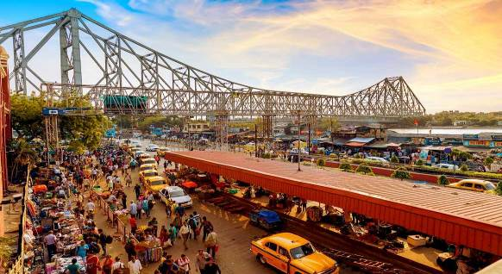
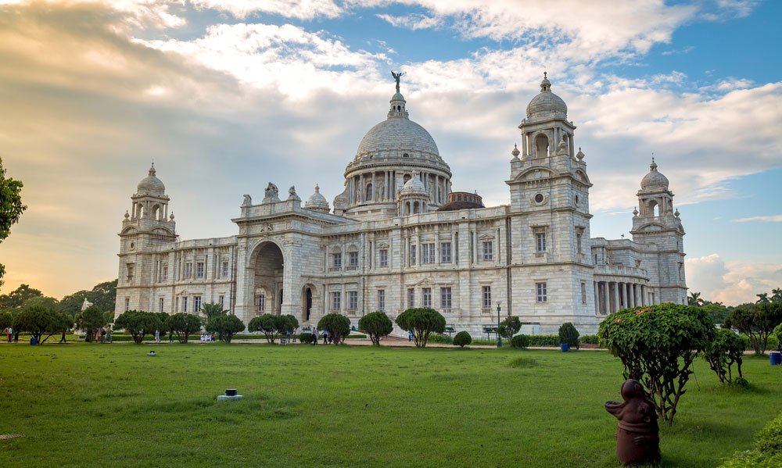
We get off the boat and head into Kumar Tuli to see another fascinating aspect of Kolkata – its many clay sculpters who make beautiful models of gods and goddesses for the festivals and to adorn peoples’ gardens and homes.

Later we drive past Fort William, the Eden Gardens, Dalhousie Square and the Writer’s Building, St John’s Church and the Governor’s Residence. See the Victoria Memorial, Kolkata’s imposing white marble dream inaugurated by the Prince of Wales in 1921, and St Paul’s Cathedral.

Lunch at a city restaurant

Visit the Missionaries of Charity, the home of the Late Mother Teresa. You may also visit the home, and now University, of the famous Bengali Nobel Laureate, Rabindranath Tagore. One of the leading families of the Bengali Renaissance, the family lineage is rich in accomplishments in the fields of art, culture, science and literature.

Overnight : Kolkata
Meals : Breakfast & Lunch

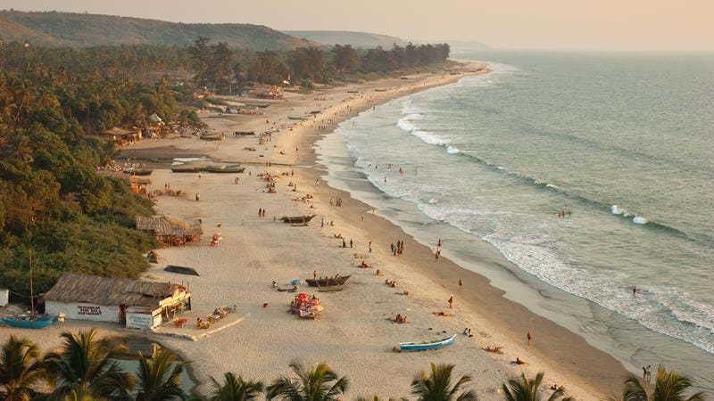

DAY 9: 4 JAN`23 (WED) KOLKATA/ GOA
After breakfast, check out and transfer to airport to board Indigo flight 6E-634 (1140/1425hrs) to Goa.

Variously known as "Pearl of the Orient" and a "Tourist Paradise", the state of Goa is located on the western coast of India in the coastal belt known as Konkan. The magnificent scenic beauty and the architectural splendors of its temples, churches and old houses have made Goa a firm favorite with travelers around the world. But then, Goa is much more than just beaches and sea. It has a soul which goes deep into unique history, rich culture and some of the prettiest natural scenery that India has to offer. Much of the real Goa is in its interiors, both inside its buildings and in the hinterland away from the coastal area. Goa was ruled by the Portuguese for 450 years till it was liberated from the Portuguese to form a part of India on 19th December 1961.

Meeting and assistance upon arrival at Goa airport and transfer to the hotel.

Overnight : Goa
Meals : Breakfast & Light Lunch on board.

DAY 10: 5 JAN`23 (THU) GOA
Breakfast at the hotel.

Full day Business Meetings

Overnight :Goa
Meals :Breakfast

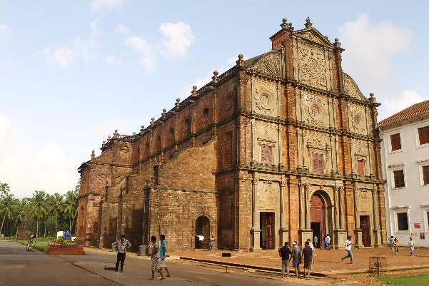

DAY 11: 06 JAN`23 (FRI) GOA / MUMBAI
After breakfast proceed for city tour of Goa.

Church of St. Francis : A stunning and charming building, the Church of St. Francis of Assisi is located in Old Goa at a distance of some 10 kilometers from the capital city, Panaji. The Church of St. Francis of Assisi is at the same complex in which Se Cathedral is located. The Church of St. Francis of Assisi of Goa was built during 1517-1521 AD

Basilica of Bom Jesus: One of the most popular churches in Goa, the Basilica of Bom Jesus truly deserves to be given the status of a World Heritage Site. It is located in Old Goa which was the capital city during the Portugal rule. The Basilica of Bom Jesus is famous for the preserved mortal remains of St. Francis Xavier.

Se Cathedral: The Se Cathedral of Goa is located in old Goa, and is around 9 kilometers from the capital city Panaji. The Se Cathedral of Goa is dedicated to St. Catherine of Alexandria.

Lunch at a city restautant

After the tour transfer to airport to board Indigo flight 6E 6386 (1840/1955hrs) to Mumbai.

Upon arrival at Mumbai airport transfer to the hotel.

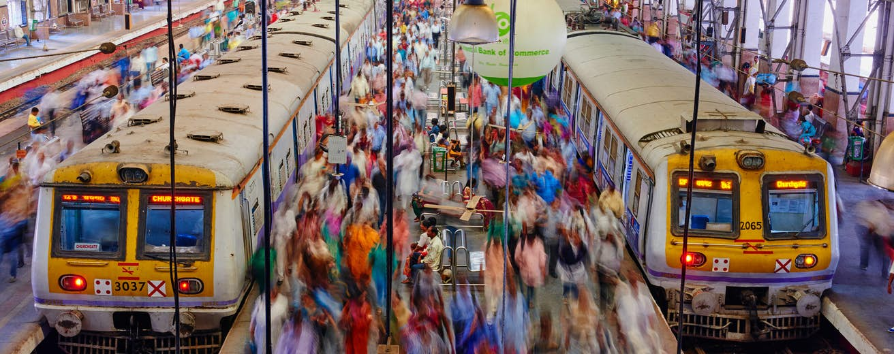
Mumbai (Bombay) is the vibrant and pulsating capital of Maharashtra. For over a century, Mumbai has been a commercial and industrial centre of India with a magnificent harbour, imposing multi-storied buildings, crowded thoroughfares, busy markets, shopping centers and beautiful tourist spots. The British acquired Mumbai from the Portuguese in 1665 and handed it over to the East India Company in 1671 for a handsome annual rent of Sterling Pounds 10 in Gold! Later, these seven islands were joined together by causeways and bridges in 1862.

Overnight: Mumbai
Meals: Breakfast & Lunch

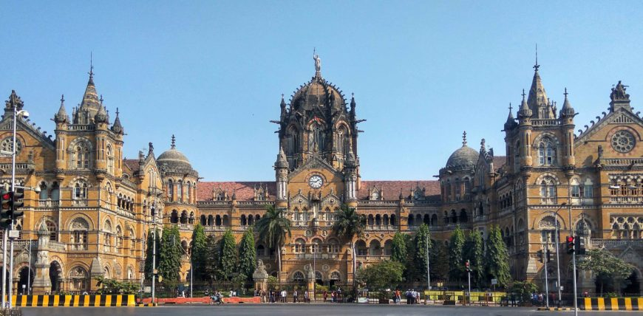

DAY 12: 07 JAN`23 (SAT) MUMBAI

Breakfast at the hotel.

Half day Business Meeting at NMIMS

Afternoon, get a taste of what Bombay is famous for the world over – Bollywood!
Discover why Mumbai is the home of the Bollywood movie industry, producing more films than even Hollywood and in many regional languages at that. Get to appreciate the “Business of Bollywood” and get see a Dance Show based on a film, a combination of Indian formal and folk music and dance fused with Middle Eastern techniques. Bollywood dances have evolved as a unique and energetic style. Perhaps you will even get a chance to learn some dance moves!

Overnight : Mumbai
Meals : Breakfast & Lunch

DAY 13: 08 JAN`23 (SUN) MUMBAI
Breakfast at the hotel.

OPTIONAL TOUR
Morning, visit to the Elephanta Caves - 22 kms off the coast of Bombay and an hour’s ride by motor launch from the Gateway of India. The cave temples of Elephanta date back to the 7th century. Four rows of massive columns cut into solid rock form three magnificent avenues, leading to the outstanding three-headed sculpture representing `Brahma the Creator’, `Vishnu the Preserver’ and `Shiva the Destroyer’. Dedicated to Shiva, the beauty and power of these phenomenal sculptures, depicting the various manifestations of Shiva, is overpowering.
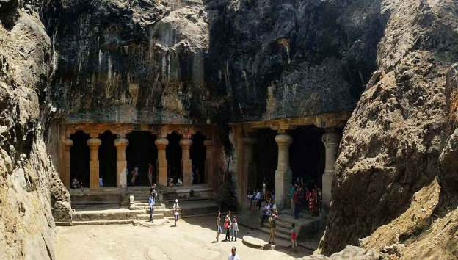

Lunch at a restaurant.

Afternoon, an Orientation Tour of the city of Mumbai, where you will get to see its many Colonial buildings and the imposing Gateway of India. Drive past the Victoria Terminus railway station (presently known as Chhatrapati Shivaji Terminus), an architectural brilliance of the British Era. The station was designed by Frederick William Stevens, a consulting architect in 1887-1888. It took ten years to complete and was named "Victoria Terminus" in honour of the Queen and Empress Victoria

*OR*

Day free for shopping or possibly an early departure home.

Evening: Farewell Dinner (this can be moved to the previous evening, if requireed)

Overnight : Mumbai
Meals : Breakfast & Dinner

DAY 14: 09 JAN`23 (MON) MUMBAI DEPARTURE
Departure tansfer to airport to board international flight back home.

Breakfast included
Check-out at 1200 noon

**********

Hotel Envisaged

Dates | City | Hotel
28 – 31 Dec’22 | Delhi | Taj Palace, New Delhi – Deluxe room
31 Dec’ 22 - 01 Jan ‘23 | Agra | ITC Mughal – Mughal Chambes
01 – 04 Jan ‘23 | Kolkata | The Oberoi Grand – Deluxe room
04 – 06 Jan ‘22 | Goa | Vivanta by Taj Panaji – Superior room
06 - 09 Jan’22 | Mumbai | Taj Mahal Towers - Deluxe sea view room

COST & CONDITIONS

Our quotation for this tour from 28 December 2022- 09 January 2023 in US Dollars:
Basic cost (based on minimum 15 paying persons) | Rate in US Dollars
Tour cost based on accommodation in single rooms, transportation by an air conditioned coach and Economy Class air tickets on the Delhi/ Kolkata /Goa/Mumbai sectors | US$ 4895 per person
Tour cost based on accommodation on twin-sharing basis, transportation by an air conditioned coach and Economy Class air tickets on the Delhi/ Kolkata/Goa/Mumbai sectors | US$ 3670 per person
Spouse/Partner (Special Price): Based on sharing the Delegate’s Single Room (now double occupancy), inclusive of all tours with group, meals, monument entrances and economy class air tickets on Delhi/ Kolkata /Goa/Mumbai sectors | USD 1475 per person

Cost includes:
- Accommodation on single room / twin room basis for a total of 12 nights on bed & breakfast basis, including immediate occupancy on arrival in Delhi on Day-2
- Meals as per the program (Lunches & Dinners)
- Arrival/departure transfers with assistance, sightseeing, local usages & long drives by an Air-conditioned Coach
- English speaking local guides for city tours as per the program
- Monument entrance fees during sightseeing tours
- Rickshaw ride in Old Delhi
- River cruise on Hoogly river in Kolkata
- Bollywood Experience in Bombay (Mumbai)
- Packaged water in the coach throughout the tour
- Tips and gratuities
- Economy class air tickets on the Delhi/ Kolkata /Goa/Mumbai sectors.
- Accompanying Tour Director throughout
- All currently applicable taxes

Cost does not include:
- International flights
- Meals – other than those specified (it is assumed that lunches on Business days will be taken care of by the Educational partner)
- Any meeting rooms at the hotels (additional chargeable, if required)
- Any expenses of a personal nature such as telephone calls, laundry, table drinks and beverages.
- Charges for movie cameras at the monuments
- Any unprecedented hike in government taxes, hotel rates, fuel prices that may be applicable in the future.
- Any other expenses not specifically mentioned to have been included above.

VALIDITY: FOR THIS PARTICULAR TOUR ONLY

Payments:
- 20% deposit payable on the confirmation of the tour.
- Balance 80% payable 30 days prior to commencement of tour.

Cancellations:
- Deposit once paid is non-refundable
- 100% cancellation charges will apply if cancelled within 30 days of commencement of tour.

