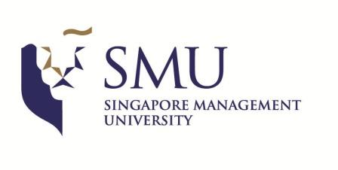
FACULTY POSITION IN STRATEGY, IB, CSR AND SUSTAINABILITY, INNOVATION, ORGANIZATRION THEORY, OR ENTREPRENEURSHIP

STRATEGY & ORGANISATION AREA
LEE KONG CHIAN SCHOOL OF BUSINESS
SINGAPORE MANAGEMENT UNIVERSITY

Singapore Management University’s Strategy & Organisation group invites applications for an open-rank tenure-track faculty position.

We are seeking candidates in one of the following areas: (a) Strategy, (b) International Business/Global Strategy, (c) Environmental Sustainability and CSR, (d) Innovation/Technology Management, (e) Organization Theory, or (f) Entrepreneurship at the Assistant Professor, Associate Professor and Full Professor levels.

We seek candidates who are conducting rigorous, impactful, and interesting research, and have high-quality publishing and research records commensurate with the rank they are applying for.

Successful candidates can expect excellent conditions for research and teaching, a collegial and supportive environment, and the experience of living, teaching, and conducting research in a dynamic and exciting region of the world.

SMU offers an internationally competitive compensation and research support package including relocation benefits and child education funding.

Further information about the Strategy & Organisation group can be found at
http://business.smu.edu.sg/business/disciplines/strategy-and-organisation/welcome.

General information about SMU can be found at www.smu.edu.sg.

APPLICATION PROCEDURES

Candidates should submit a full application by 25th September 2022 consisting of: (1) a letter with their research and teaching statement, (2) a CV, (3) three samples of research, (4) evidence of teaching ability, and (5) three letters of reference. All application materials are to be sent using the following link (Candidates can upload the reference letters as attachments under their profile via the system, or have them sent directly to managementcv@smu.edu.sg).

https://smucareers.taleo.net/careersection/smu_ext_ft/jobdetail.ftl?job=2200005X&tz=GMT%2B08%3A00&tzname=Asia%2FSingapore

Full Professors and established Associate Professors may send just a cover letter and CV to managementcv@smu.edu.sg with the subject heading “Tenure-track Application”, and will be considered on an ongoing-basis.

We will consider candidates until the positions are filled.

