Transforming Business and Education for Flourishing - Rethinking Foundations and Practice
Part of the PRME Responsible Management Week
Overview: In a time of polycrisis the economic system, businesses, and business education are under pressure to adapt. Leadership requires a different paradigmatic framework as the world is struggling to achieve the UN Sustainable Development Goals. This conference brings together leaders in various fields such as social innovation, evolutionary science, and humanistic leadership that work to transform the current economic system to become life-conducive. The convenors host research workshops to develop and cocreate papers that advance new-paradigm thinking about foundations for economics, business and business education. The conference also brings together leading academics, companies, and practitioners, to connect and explore partnerships. Finally, the conference hosts two days of professional capacity building with regard to pedagogy and community development.
Dates: June 3 to June 7, 2024
- Research days: June 3- June 4
- Partnership day: June 5
- Professional Development: June 6 – June 7
Location: Fordham University, Gabelli School of Business, New York City
Audience: Business School Professors, Humanistically oriented Academics and Practitioners working to transform the economic system
Partners: PRME, an Initiative of the UN Global Compact, Ashoka U, Humanistic Leadership Academy, Harvard Human Flourishing Program, Prosocial World, International Humanistic Management Association, Conscious Business Europe, International Association for Business and Society, Academy of Management (SIM/MSR Divisions)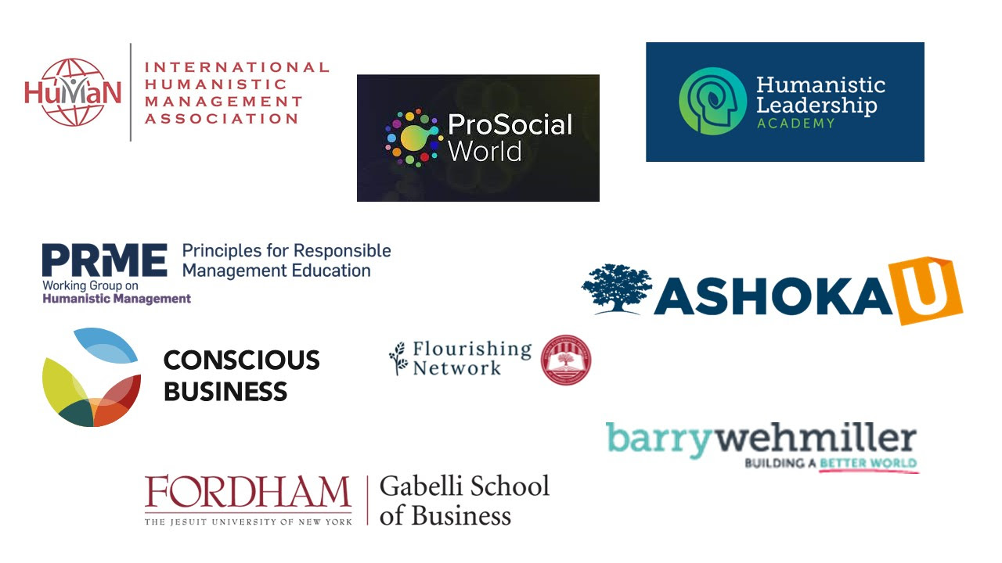

Preliminary Program

Monday, June 3
9- 10:30 Research groups workshop:
Topics:
- New Paradigm for Business Leadership- an evolutionary perspective
- Love and Organizing
- Artificial Intelligence and Flourishing
- Wisdom, Transformation and Flourishing
- Social Innovation
- Mindfulness and Leadership
- Dignity and Organization
- Arts and Sustainability
- Impact Measurement
- Smart and Regenerative Cities
- Getting UnStuck (AMP Special Issue)
Outcome: Draft ideas and research questions for HMJ Special Issue

Break
11- 12:30 Parallel Paper Sessions

1- 2pm Lunch: David Sloan Wilson- Keynote
Rethinking the Foundations of Business and Business Education- The evolutionary perspective

2:15- 3:45 Research groups workshop:
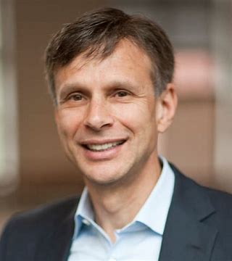
Topics:
- New Paradigm for Business Leadership- an evolutionary perspective
- Love and Organizing
- Artificial Intelligence and Flourishing
- Wisdom, Transformation and Flourishing
- Social Innovation
- Mindfulness and Leadership
- Dignity and Organization
- Arts and Sustainability
- Impact Measurement
Outcome: Draft outline for article for HMJ Special Issue

4:15- 5:45 Parallel Paper Sessions

Tuesday: Rethinking the Curriculum
With AshokaU/ UN PRME/ Humanistic Leadership Academy/ Evolution Institute /IAJBS Inspirational Paradigm
9:00 - 930 Reflecting on the prior day

9:30 - 10:15 Transforming Business and Education for Flourishing
- Heather McCleoud, Ashoka U
- Gisela Veritier, ICDA Argentina, Head of Inspirational Paradigm for Jesuit Business Education
- Monika Lopez, President of CLADEA

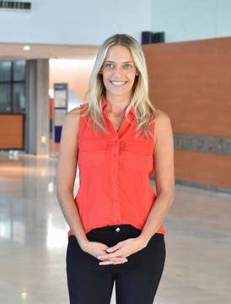
10:30 - 11:30 The Foundational Role of Dignity: Dr. Donna Hicks, Harvard University

Humanizing Interventions for Flourishing
- I5 UN PRME / Lego Foundation
- Mindfulness
- Inner Development Goals

Workshops on Redesigning Curriculum

Rethinking the Paradigmatic Foundations of Business Education
- David Sloan Wilson
- Michael Pirson

Learning from Ongoing Curriculum Transformation
- Conscious Business Europe, Konstantin Mudrack
- Inspirational Paradigm for Business Education, Itzel Palomares
- Human Energy, Ellen Rigsby
- Humanistic Leadership Academy: David Capistran

Workshops on Redesigning Curriculum

Wednesday: Exploring and Enabling Effective Partnerships with Stakeholders

Breakfast hosted by Responsible Business Center
With UN PRME/ AshokaU/ Barry-Wehmiller/ Humanistic Leadership Academy/ Conscious Business Europe/ Conscious Capitalism/ B-Lab/ NOW Partners/ Harvard Human Flourishing Program

Research Partnerships:
Matthew Lee, Harvard Human Flourishing Program
Ayse Yemiscigil, Fordham Unversity
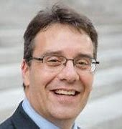

Partnering with System Actors
B-Lab/ Ashoka / Conscious Capitalism, Net Impact/ Ranking/ Ratings/IAJBS
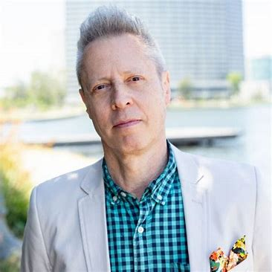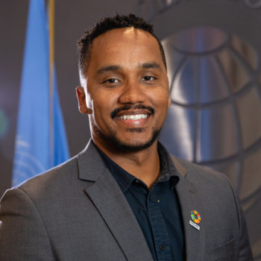

Cristina Gimenez-Thompson, ESADE , Taskforce CoChair of Inspirational Paradigm
Peter Lupoff, Fordham , Former CEO of Netimpact
Gustavo Loiola, UN PRME
Partnering With Practice:
- Bob Chapman, CEO of Barry Wehmiller
- Raj Sisodia, Founder of Consicous Capitalism, Distinguished Professor Tec de Monterrey Mexico

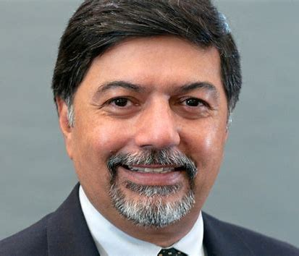

Thursday/ Friday: Capacity building For Leading Effective Change and Humanistic Leadership
AshokaU/ Humanistic Leadership Academy
Thursday: June 6
- AshokaU Changeleader Convening
- Humanistic Leadership Cohorts Convening

Collective Reflection
- Where are we?
- What are the successes
- What is missing?

Workshop I: Enhancing Our Individual Changemaking Capacity

Workshop II: Enhancing our Collective Changemaking Capacity

Workshop III :
Experiencing Whole Person Learning for Team Building with Jazz at Lincoln Center/ Alvin Ailey Dance Company (TBC)

Friday: June 7
Workshop I: Enhancing Our Individual Changemaking Capacity
Workshop II: Enhancing our Collective Changemaking Capacity

Otto Scharmer: Transforming Systems towards Flourishing

Call for Extended Abstracts
Transforming Business and Education for Flourishing - Rethinking Foundations and Practice

Humanistic Leadership Conference at Fordham University, New York, June 3-7, 2024

Part of the PRME Responsible Management Week

Partners: PRME, Ashoka U, Humanistic Leadership Academy, Harvard Human Flourishing Program, Prosocial World, International Humanistic Management Association, Conscious Business Europe, International Association for Business and Society, Academy of Management (SIM/MSR Divisions)

Call for Extended Abstracts
In a time of polycrisis the economic system, businesses, and education are under pressure to adapt. Leadership requires a different paradigmatic framework as the world is struggling to achieve the UN Sustainable Development Goals. This conference brings together leaders in various fields such as social innovation, evolutionary science, and humanistic leadership that work to transform the current economic system to become life-conducive. We also invite those working on transforming education and specifically business education to equip changemakers to effectively transform organizations and systems at large.
We call for extended abstracts of research that can provide guidance and insights in terms of how leaders and managers can more effectively address the polycrisis. We invite contributions from the fields of social innovation, regenerative leadership, humanistic management and beyond. In the below we list possible areas of contribution categorized as problematique, paradigmatic perspectives, Input pillars, transformation mechanisms, and outcomes (non-exhaustive). We are inviting specific contributions to areas such as:
- Getting UnStuck (AMP Special Issue)
- New Paradigm for Business Leadership- an evolutionary perspective
- Teilhard de Chardin, Noosphere and Business
- Dignity and Organization
- Love and Organizing
- Artificial Intelligence and Flourishing
- Wisdom, Transformation and Flourishing
- Social Innovation
- Mindfulness and Leadership
- Arts and Sustainability
- Impact Measurement
- Smart and Regenerative Cities

Problematique
- Getting UnStuck
We invite academics and practitioners to think about how we can get unstuck. In times of polycrisis, with the many commitments by governments, businesses, and many people of good will all across the globe it seems something is missing; a lack of coordination, a system reboot, a global go’vernance system, effective government, leadership for the public good, you name it. In this track we are looking to see what thinking exists that is informed by the best of theory and practice to get humanity unstuck.
Grand Paradigmatic Perspectives
- New Paradigm for Business Leadership- an evolutionary perspective
To address the bigger issues at hand we arguably need to rethink the foundations of our theories. Those paradigmatic assumptions inform who we are as human beings, the nature of organizations and the purpose of organizing and leading. We particularly invite contributions from the natural sciences and evolutionary perspectives.

- Teilhard de Chardin, the Noosphere and Business
One of the broader foundational challenges and paradigmatic innovations is provided by Jesuit Theologian and evolutionary scientist Teilhard de Chardin. We invite all interested in the concepts of the noosphere and its applications to business and leadership to consider submission.

Input Pillars of New Paradigm

- Dignity and Organization
Dignity is critical to any functioning system and its neglect a primary flaw in the dominant paradigm. We invite further conceptual and applied research regarding dignity specifically in organizations and the organizing process. Potential research could examine dignity and its assessment within organizations, leading with dignity, honoring the intrinsic value of nature, honoring people like human beings as well as creating and maintaining dignity cultures in organizations.

- Love and Organizing
While many pop songs reference the power of love, these insights are rarely examined within the context of business, leadership, and organizations. We invite contributions that explore love conceptually and as a source of transformation in the contexts of business, leadership and organizations.

Transformational Mechanisms and Interventions

- Social Innovation
The field of social innovation and social entrepreneurship has provided insights into alternative ways of organizing. As the field is emerging, we invite further contributions from this perspective and appreciate insights into the paradigmatic challenges and potentially scalable contributions to human flourishing. We also invite pedagogical insights into how social innovation can be taught within organizations.

- Regeneration and Regenerative Value Creation

The term regeneration has gained new currency in the field of sustainability research arguing that more than sustainability is required. The field of regenerative agriculture and forestry are paving the way towards regenerative value creation as a potential avenue to rethink company action. We invite contributions that more deeply examine these conceptual avenues and provide practical insights for transformation.

- Wisdom, Transformation and Flourishing
Wisdom is for philosophers and sometimes you might end up lucky when ruled by a philosopher CEO. At the same time, wisdom and discernment are seemingly becoming more critical than ever for successful leaders. To navigate transformation towards flourishing in the polycrisis, what kinds of wisdom are needed and how can we educate for it. Submissions exploring practical wisdom at work are welcome.

- Mindfulness, Well Being and Leadership
Mindfulness has long been hailed as a powerful intervention to transform individuals and organizations. At the same time, it has been criticized because corporations have captured it to pacify employees. We invite contributions that examine the transformational power of mindfulness for well-being, flourishing and leadership in the context of system transformation.

- Artificial Intelligence and Flourishing
Artificial Intelligence may be the most potent and transformative technology yet and it can be harnessed for good and bad; much like any technology. So, what are ways humanity can systematically harness benefit and advance human flourishing on this shared planet? Research exploring the challenges and contributions of AI to human flourishing are invited.

- Arts and Sustainability
While Mintzberg and others call management an art, the arts themselves play a minor role in the context of business organizations. In this call we invite those researching how the arts can be successfully employed to transform people and organizations towards sustainability.

Outcomes

- Sustainable Development Goals and Business Leadership
As the world is failing to be on track to meet the sustainable development goals, how can businesses and education shift to empower the necessary transformation. We invite holistic and practical perspectives that can inform leadership at the level of business, education, societal organizations, and public policy.

- Impact Measurement
To assess the impacts of transformative practices, new assessments and impact measures are needed. There are ongoing efforts globally that aim to capture ecological, social, and governance related impacts. Yet, further research is needed to assess the potential for paradigmatically appropriate impact measures that transcend the techno-economistic paradigm.

- Smart and Regenerative Cities
Beyond organizations and businesses we are looking to see what we can say about creating smart and regenerative cities that support human flourishing.

These extended abstracts are a baseline for invitation to present at the conference as well as for consideration to several special issues, including for Academy of Management Perspectives and Humanistic Management Journal. To have your contribution considered for invitation submit 1000 to 1500 Word Extended abstract to Call for Extended Abstracts Transforming Business and Education For Flourishing - Rethinking Foundations and Practice - Due by April 15th (google.com) or info@humanisticmanagement.international by April 15, 2024.

