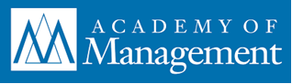 | 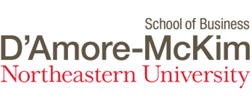

Call for Submissions
2022 IM Division D'Amore-McKim School of Business, Northeastern University Award for the Best Dissertation in International Management

The IM Division D'Amore-McKim School of Business, Northeastern University Award for the Best Dissertation in International Management is presented to the best dissertation submitted to the International Management Division. A plaque is awarded to the author of the winning dissertation.

Eligibility Criteria

- The award competition is open to all Ph.D. and D.B.A. students who have successfully completed their dissertations during the 2021 calendar year.
- Dissertations submitted to other competitions are eligible.
- All applicants must be members of the IM Division.
- The dissertations must contribute to basic or applied knowledge on topics within the domain statement of the IM Division.

Domain Statement

The International Management Division focuses on research in management and organization theory, research, and practice with a cross-border or cross-cultural dimension. Major topics include: the international competitiveness of firms, industries, and nations; the cross-border management of operations, including multi-country, multi-unit strategy formulation and implementation; evolving organizational forms and management practices in cross-border business; the cross-border differential impact of cultural, social, economic, technological, political, and institutional forces on strategies, organizational forms, and management practices; and comparative management studies involving two or more countries.

Submission Guidelines

- Submit electronically a 10-page, double-spaced abstract, with margins of one inch (2.54 cm) on every side and in no smaller than 12-point font. This abstract should include a description of the dissertation’s objective, theoretical foundations, relation to prior research, methodology, findings, limitations, and contributions to the field of international management. Reference lists are not included within the 10-page limit, but all other text, figures, tables or illustrations are included.
- Submit the abstract in PDF format so that there is no author identification information.
- Within the body of the submission e-mail, but not the abstract file, please indicate the university you graduated from, your dissertation chair(s), and your month and year of graduation.
- Please write “AOM IM Division Best Dissertation Award Abstract” as the subject header.
- Submit your abstract via e-mail to the Best Dissertation Award Committee Chair at vorad@newpaltz.edu.

The extended submission deadline for abstracts is February 15, 2022.

Evaluation Process

- The IM Division Best Dissertation Award Committee will conduct the first round of reviews of the abstract submissions and select three to five finalists based on the quality of their abstracts.
- The finalists will then submit their full dissertations for further review and selection.

Obligations of Finalists

Being selected as a finalist is an honor. Finalists are required to present their dissertations at a specially designed session during the 2022 AOM Annual Meeting. Please submit your abstracts only if you agree to this requirement and agree to attend the division’s Business Meeting where the winner is announced.

