Call for Youth Editorial Board (YEB) Member: Journal of Digital Economy (JDE)
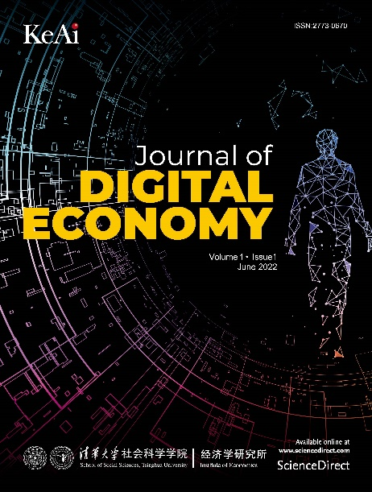
Journal of Digital Economy (ISSN: 2773-0670) is a peer-reviewed, open access journal. It is co-founded by Institute of Economics, Tsinghua University in China and Ke Ai Publishing (Founded by two of the world’s leading STM publishers, China Science Publishing & Media and Elsevier). JDE sheds light on how this digital era is expanding, restructuring and challenging existing knowledge and traditional methodology. It is a platform for both theoretical and empirical contributions to multiple disciplines, including but not limited to, Economics, Management, Sociology, Political Economy, Computer Science and Environmental Science. For more information, please refer to:
https://www.sciencedirect.com/journal/journal-of-digital-economy
https://www.keaipublishing.com/en/journals/journal-of-digital-economy/
JDE is committed to building an internationally renowned first-class journal in the field of digital economy. For the purpose of further improving the quality and enhancing the international impact of JDE, and setting up an international academic exchange platform for junior scholars, we intend to organize a Young Editorial Board (YEB) to give full play to the role of junior scholars.
We are now sincerely inviting excellent junior scholars from all over the world in the field of related digital economy to join us. We look forward to your excellent academic expertise and passion for international academic journals, and let us work together to make some contribution to the international development of JDE.
YEB will serve for one year, after which you can apply for conversion to Editorial Board (EB). Specifically, YEB needs to take the following responsibilities:
- Write or invite at least ONE manuscript during the fixed term;
- Assist the editorial department in regular editing and reviewing;
- Actively participate in publicity work, including but not limited to operating new media platforms with the editorial department and assisting academic conferences hosted by JDE.
Right now, we are recruiting 10 YEB members. Places are limited, so first come and first served. The detailed application and selection process is as follows.
- Apply via email
Please submit your application via email with the subject line "JDE Young Editorial Board Member-Name" and attach the following documents to ytq21@mails.tsinghua.edu.cn.
- Personal statement - including a description of your expected contribution (1 page)
- CV-including name, contact information, current institution, research direction, education experience, scientific research experience, a list of representative papers, awards, etc.
- Selection process
Initial screening of application materials → Selection by the Editorial Committee → Interview → Notification by email → Announcement on the website → Award of appointment letter
The deadline for this recruitment is 30th June, 2023. Please be advised that we will be reviewing each application once submitted. We may not reply to every email, but applicants who pass the preliminary screening will receive a response within two weeks.
------------------------------
Ke Rong
Professor, PhD(Cantab.)
Editor-in-Chief, Journal of Digital Economy
Institute of Economics, School of Social Sciences,
Tsinghua University, Beijing, China,100084
Phone: +8618515572787
Email: r@tsinghua.edu.cn
------------------------------

