Leveraging Digitalisation for the Internationalisation and Growth of Ethnic Minority Businesses in the West Midlands

Department: College of Business and Social Sciences
Contract Type: Fixed Term
Basis: Full Time
Closing Date: Monday 3rd June at 23.59 (UK time)
Supervisors: Professor Monder Ram and Dr Vahid Jafari-Sadeghi

Applications are invited for a three-year PhD studentship, supported by the College of Business and Social Sciences to be undertaken within the Department of Economics, Finance, and Entrepreneurship at Aston University.

The position is available to start in October 2024.

Financial Support

This studentship includes a fee bursary to cover the home or overseas fees rate, plus an annual maintenance allowance to cover the full 3 years (£19,237 pa in 2024/25).

Background to the Project

Aston Business School is pleased to present a pivotal research opportunity titled "Leveraging Digitalisation for the Internationalisation and Growth of Ethnic MinorityBusinesses in the West Midlands." This project aligns with Aston University’s Aston 2030 strategy, emphasizing innovation, global influence, and regional development, and also resonates with the research focus of the Department of Economics, Finance, and Entrepreneurship and the Centre for Research in Ethnic Minority Entrepreneurship (CREME).

The research aims to understand how digitalisation influences ethnic minority businesses (EMBs) in the West Midlands, a region of significant economic and cultural diversity.EMBs contribute substantially to the UK economy; however, they face unique challenges such as limited resources, digital literacy issues, and specific cultural or contextual obstacles. This project explores several key aspects: how digitalisation enhances the growth and internationalisation of EMBs in the West Midlands, the drivers and barriers for EMBs in adopting digital technologies, and how institutional arrangements and support mechanisms enable EMBs to leverage their cultural and ethnic ties for internationalisation.

Employing an interdisciplinary approach, this research integrates findings from ethnic minority entrepreneurship, digitalisation and technology adoption, and international business debates. The theoretical contribution is twofold: advancing ethnic minority entrepreneurship literature by examining the strategic use of digitalisation for growth and internationalisation, and contributing to international business literature by investigating how EMBs orchestrate ethnic connections and digitalisation for international growth. The practical impact of this research is significant, especially for the Innovation Alliance for the West Midlands (IAWM), providing insights into EMBs' challenges in adopting digitalisation and their potential for growth in the digital economy.

The methodology is a mixed-method design combining action research with a survey. Action research involves collaborating with EMBs as co-researchers, encompassing diagnosis, planning, action, and reflection stages. The survey component assesses EMBs on their digital adoption, uses, perceptions, and impact on growth and internationalisation. This research opportunity is not just a contribution to academic study but also has the potential to influence real-world business practices and policies, particularly in enhancing the capabilities of EMBs in the digital economy. The successful candidate will gain invaluable experience and contribute to a project at the nexus of digitalisation, ethnic minority entrepreneurship, and international business, under the guidance of experienced researchers at Aston Business School.

Person Specification

The successful candidate should hold a Masters degree in business, management, or the social sciences (or related disciplines) with a Merit overall (or equivalent) with a dissertation/research element, PLUS a First or Upper Second Class Honours degree (or an equivalent qualification from an overseas institution).

We are looking for candidates with a keen interest in international entrepreneurship, digital transformation, and ethnic minority businesses. Applicants should possess a strong academic background in business, economics, or a related field. Skills in qualitative and quantitative research methodologies are essential. The ideal candidate will be highly motivated, with the ability to work independently and collaboratively, and have excellent communication skills.

Contact information

For formal enquiries about this project please contact Professor Monder Ram m.ram1@aston.ac.uk or Dr Vahid Jafari-Sadeghi v.jafari-sadeghi@aston.ac.uk

Submitting an application

Your application must include:
- English language copies of the transcripts and certificates for all your higher education degrees, including any Bachelor degrees.
- A Research Proposal Statement detailing your understanding of the research area, how you would approach the project, and a brief review of relevant literature. Be sure to use the title of the research project you are applying for. There is no set format or word count.
- A personal statement which outlines any further information which you think is relevant to your application, such as your personal suitability for research, career aspirations, possible future research interests, and further description of relevant employment experience.
- Two academic referees who can discuss your suitability for independent research. References must be on headed paper, signed and dated no more than 2 years old. At least one reference should be from your most recent University. You can submit your references at a later date if necessary.
- Evidence that you meet the English Language requirements. If you do not currently meet the language requirements, you can submit this at a later stage.
- A copy of your passport. Where relevant, include evidence of settled or pre-settled status.
Apply for this position here

Alternatively, apply here

Please select:

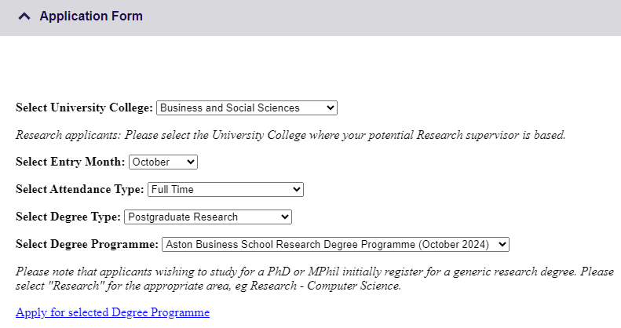

If you require further information about the application process, please contact the Postgraduate Admissions team at pgr_admissions@aston.ac.uk

